DSP PID Controller Board Bringup

Rich Rademacher

University of Waterloo/IQC March 2018

# Introduction

This document describes the bringup of the digital PID loop controller based on the Analog Devices Blackfin processor, and AKM semiconductor AK4556 A/D – D/A converter.

# Tool Chain

The board requires a Blackfin C/C++ compiler. Two choices are available: the VisualDSP++ v5.1.2 for Blackfin toolchain from Analog Devices (free 90-day trial, $5000USD purchase), and the open-source uClinux for Blackfin environment based on GNU gcc compiler and Eclipse.

This bringup will focus on the GNU toolchain.

## Gnu Toolchain

The uClinux toolchain is available from

<https://sourceforge.net/projects/adi-toolchain/files/2014R1/2014R1_45-RC2/blackfin-toolchain-win32-2014R1_45.exe/download>.

## Eclipse

The interactive desktop environment (IDE) from Eclipse uses the GNU toolchain. Instructions are at <https://blackfin.uclinux.org/doku.php?id=toolchain:eclipse:install>

First download the current Eclipse for C/C++ at <http://www.eclipse.org/downloads/>.

Enable CDT tools

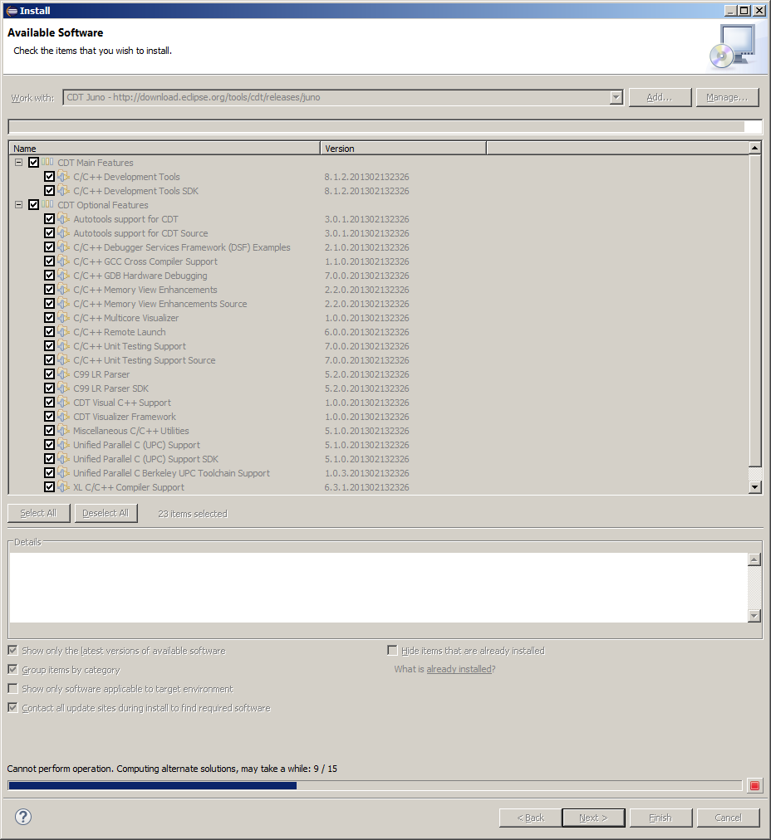

Add Blackfin plugins from <https://sourceforge.net/projects/adi-toolchain/files/eclipse/update_site/>